Experiment-12
Write A Python Program For Tic Tac Toe Game
Aim
To write and execute a Python program to implement the Tic-Tac-Toe game for two players, where the first player to get three marks in a row, column, or diagonal wins.
Algorithm
- Start the program.
- Initialize a 3 × 3 game board with empty spaces.
- Assign X to the first player and O to the second player.
- Display the game board.
- Ask the current player to enter a position from 1 to 9.
- Check whether the entered position is valid.
- Check whether the selected position is empty.
- Place the player's mark in the selected position.
- Check whether the player has three marks in a row, column, or diagonal.
- If a player wins, display the winner and stop the game.
- If the board is full and there is no winner, declare a draw.
- Otherwise, switch players and repeat the process.
Code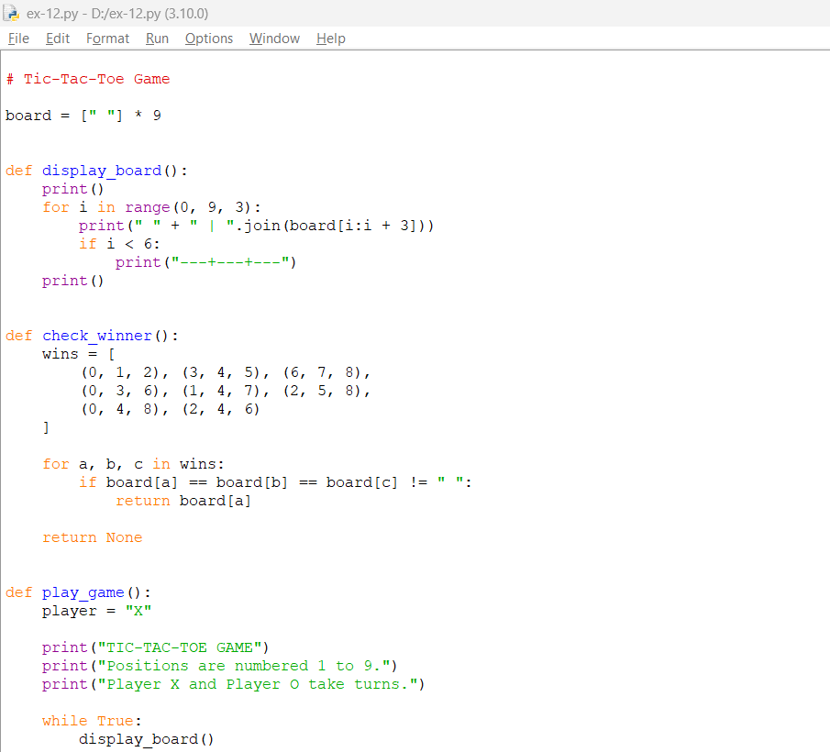
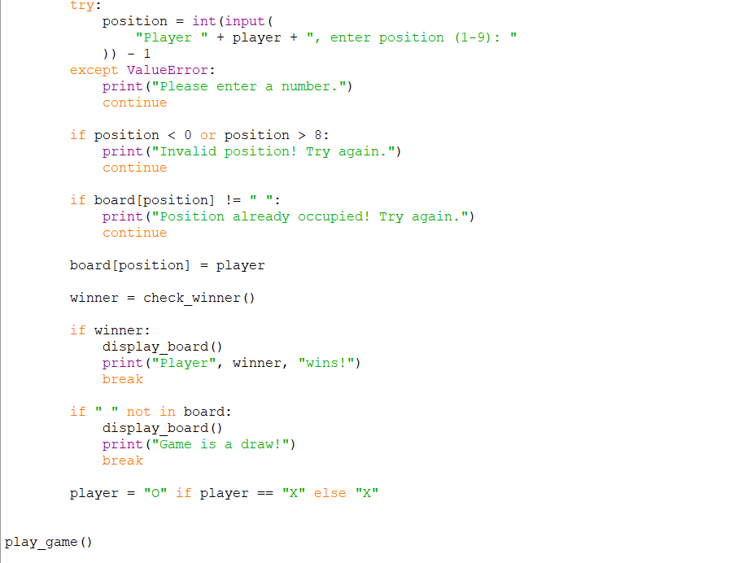
Output
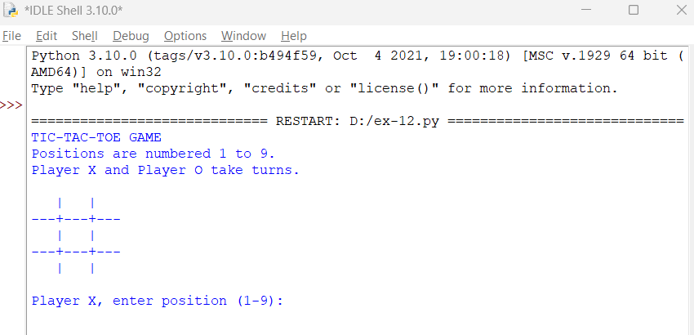
Result
The Tic-Tac-Toe game was successfully implemented. The program allows two players to take turns, checks for a winner, and declares a draw when the board is full without a winner.

